**Multimedia**

**2 Components and system requirements**

**A Listen to a sales assistant in a computer shop explaining system requirements needed multimedia Which answers best describe what she says?**

**1** Multimedia is defined the integration of video and telecommunications with traditional computing

**a** the integration of video and telecommunications with traditional c omputing.

**b** the integration of text, graphics, audio, video and animation in a single application.

**2** With multimedia encyclopedias a you have more fun but you learn more slowly

**a** you have more fun but you learn more slowly.

**b** you get much more involved than with encyclopedias

**3** Interactive games a use multimedia and virtual reality features

**a** use multimedia and virtual reality features.

**b** do not require much RAM memory

**B Listen again and complete this diagram of a multimedia system.**

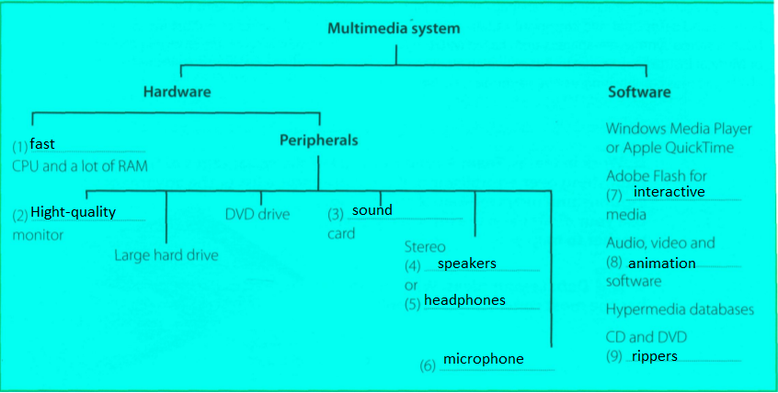

**3 Multimedia magic!**

**A Read the text and match the headings (1-4) with the gaps at the start of each paragraph (a-d)**

1 Sound, Music, MIDI

2 Products full of pictures, action and sound

3 Creating and editing movies

4 The potential of multimedia

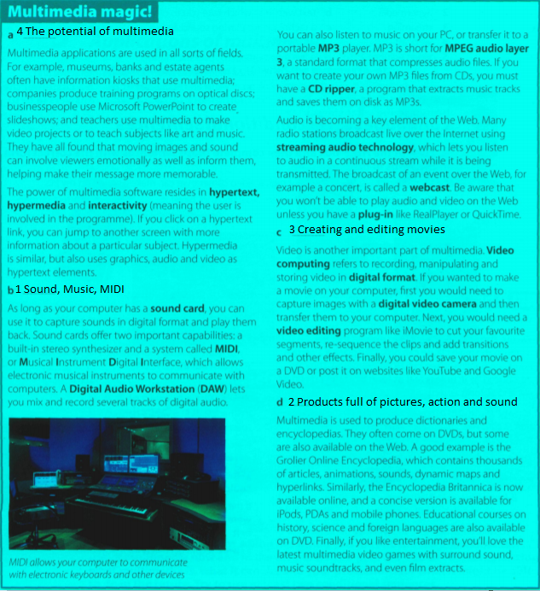

**B Correct the technical mistakes in these sentences.**

**1** Multimedia training software is distributed on ~~magnetic disks~~.on optical discs

**2** You need to have ~~MIDI~~ a sound card on your computer to hear speech and music.

**3** ~~A stereo synthesizer~~ MIDI allows your computer to communicate with electronic musical instruments

**4** A CD ripper converts CDs to ~~live streams~~ MP3 format.

**5** The Encyclopedia Britannica is only available ~~on DVD~~ in print, online, on DVD, and as a concise version for iPods, PDAs and mobile phones.

**C Match the words (1-5) with the definitions (a-e).**

**1** hypertext

**b** text with links which take you to other pages

**2** hypermedia

**e** a form of enriched multimedia which allows an interactive and dynamic linking of visual and audio elements

**3** streaming

**c** a technique for playing sound and video files while they're downloading

**4** webcast

**d** a live event broadcast over the Internet

**5** video editing

**a** the process of manipulating video images

**4 Language work: conditional sentences**

**A Look at the HELP box and then complete these sentences with the correct form of the verbs in brackets.**

1 If you bring your digital video camera, we can make a movie on my PC.

2 You won't be able to play those video files if you (not have) don’t have

3 If the marketing manager (have) had PowerPoint, she could make more effective presentations

4 If I could afford it, I (buy) ‘d buy a new game console.

5 If I had the money, I (invest) ’d invest in some new multimedia software.

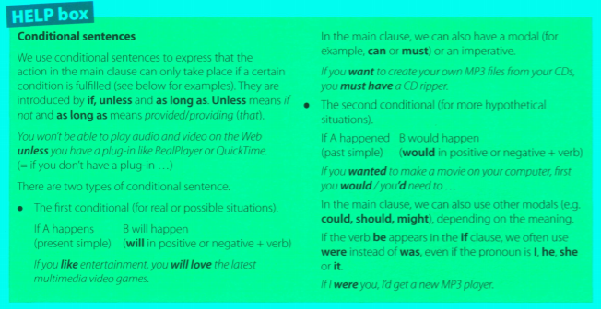

**5 Applications of multimedia A Match the descriptions (1-5) with the pictures (a-e).**

**1** Virtual reality

**2** Distance learning

**3** A business presentation

**4** A touch screen information kiosk

**5** An MMS mobile phone

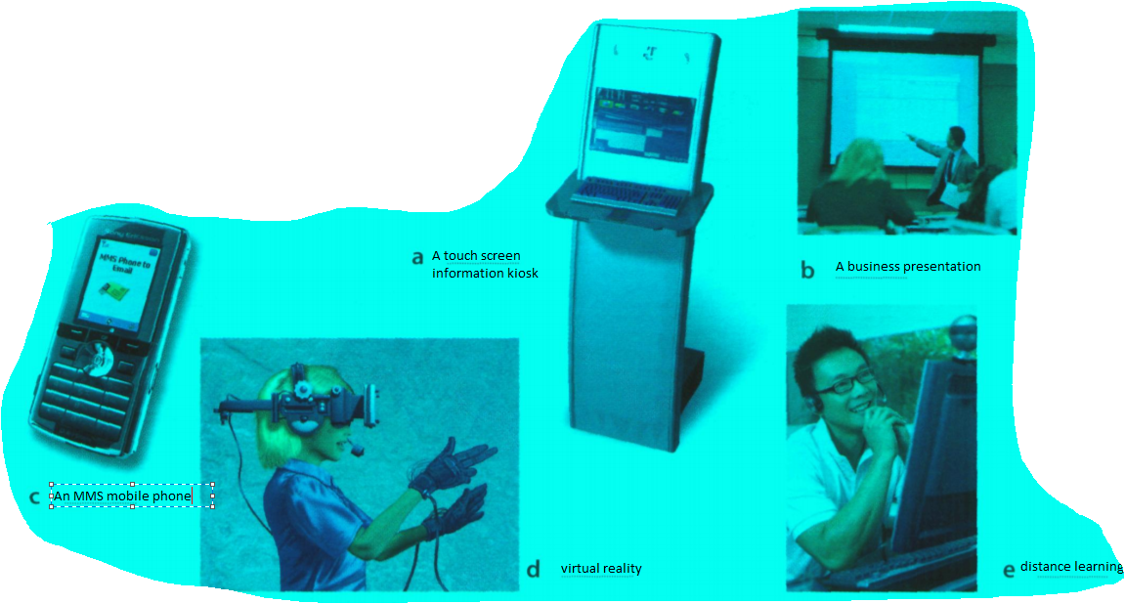

**INSTRUCTIONS FOR ACTIVITIES:**

**Page 110, ex. 2A, 2B.**

**Page 111, ex. 3A.**

**Page 112, ex. 3B, 3C, 4A.**

**Page 113, ex. 5A**